

B.V.V.Sangha's

BASAVESHWAR ENGINEERING COLLEGE (AUTONOMOUS)

BAGALKOTE - 587 102

Assignment 1

Name : Sohan.N.Aradhyamath

Prajwal Malipatil

Roll No. : 48

24

USN : 2BA21EC102

2BA21EC059

Semester : 3 Division : B

Subject : Higher Programing paradigm

Subject Code : 21UMA301C

Faculty I/C : Dr M . C . Arlimarad

***ROCK , PAPER , SCISSORS GAME USING PYTHON***

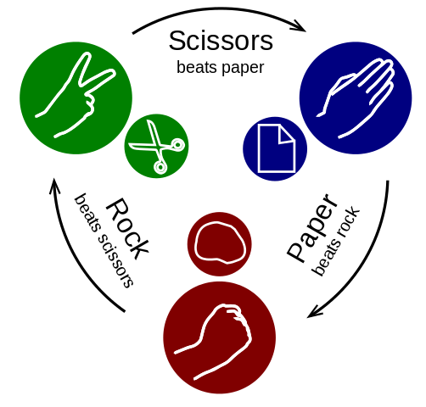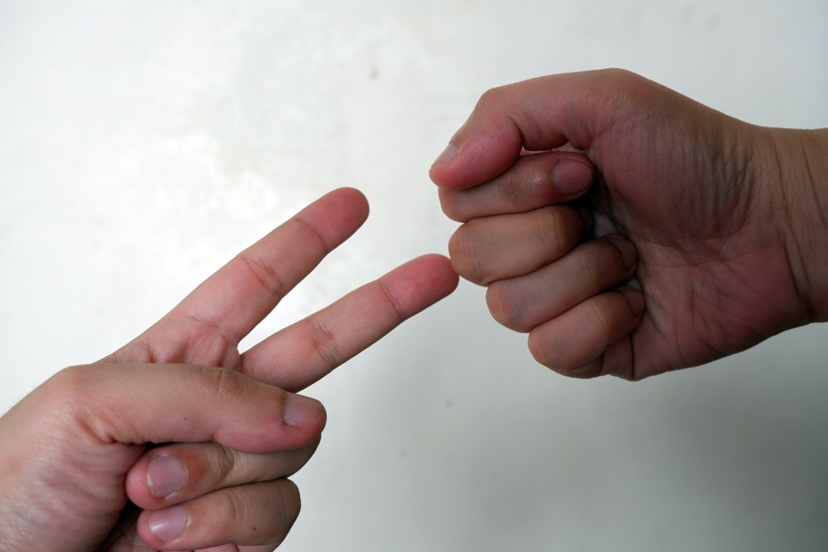

***Algorithm***

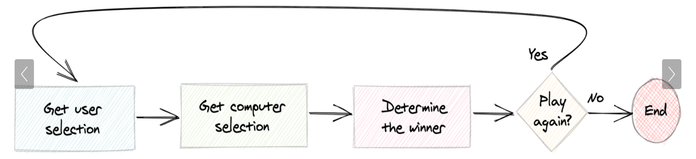

Each player selects an action and then a winner is determined. This flowchart is accurate for a single game as you’ve coded it, but it’s not necessarily accurate for real-life games. In real life, the players select their actions simultaneously rather than one at a time like the flowchart suggests.

In the coded version, however, this works because the player’s choice is hidden from the computer, and the computer’s choice is hidden from the player. The two players can make their choices at different times without affecting the fairness of the game.

Flowcharts help you catch possible mistakes early on and also let you see if you want to add more functionality. For example, here’s a flowchart that describes how to play games repeatedly until the user decides to stop:

***PROGRAM CODE***

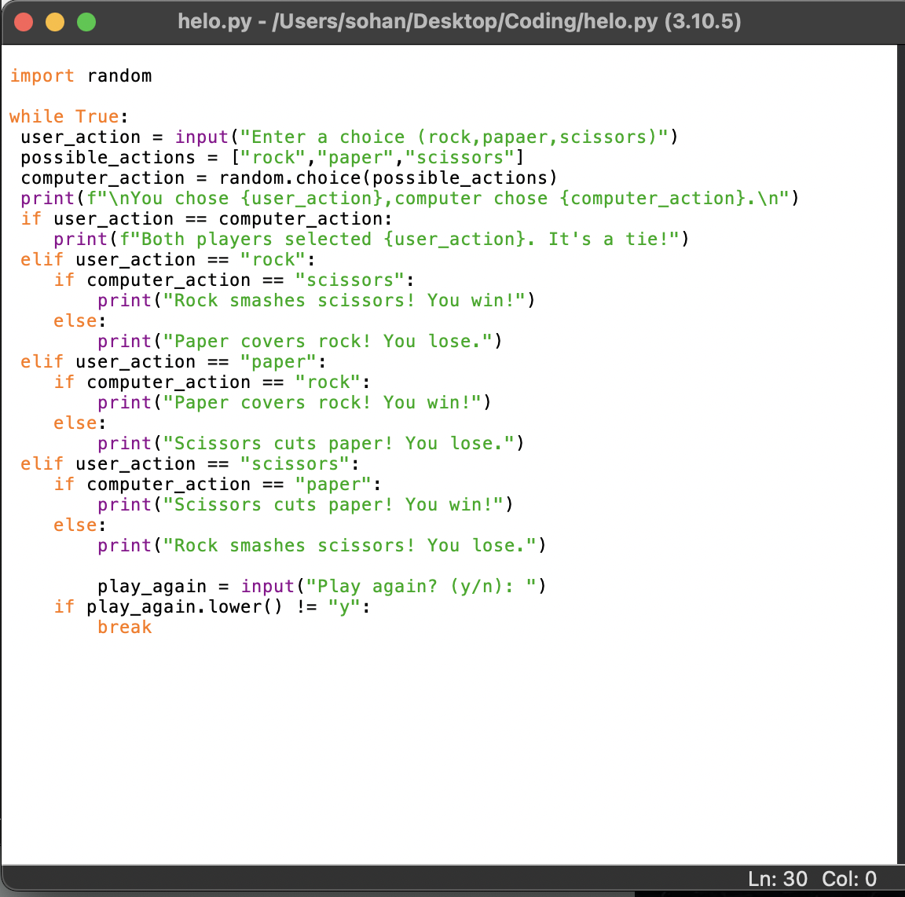

***OUTPUT***

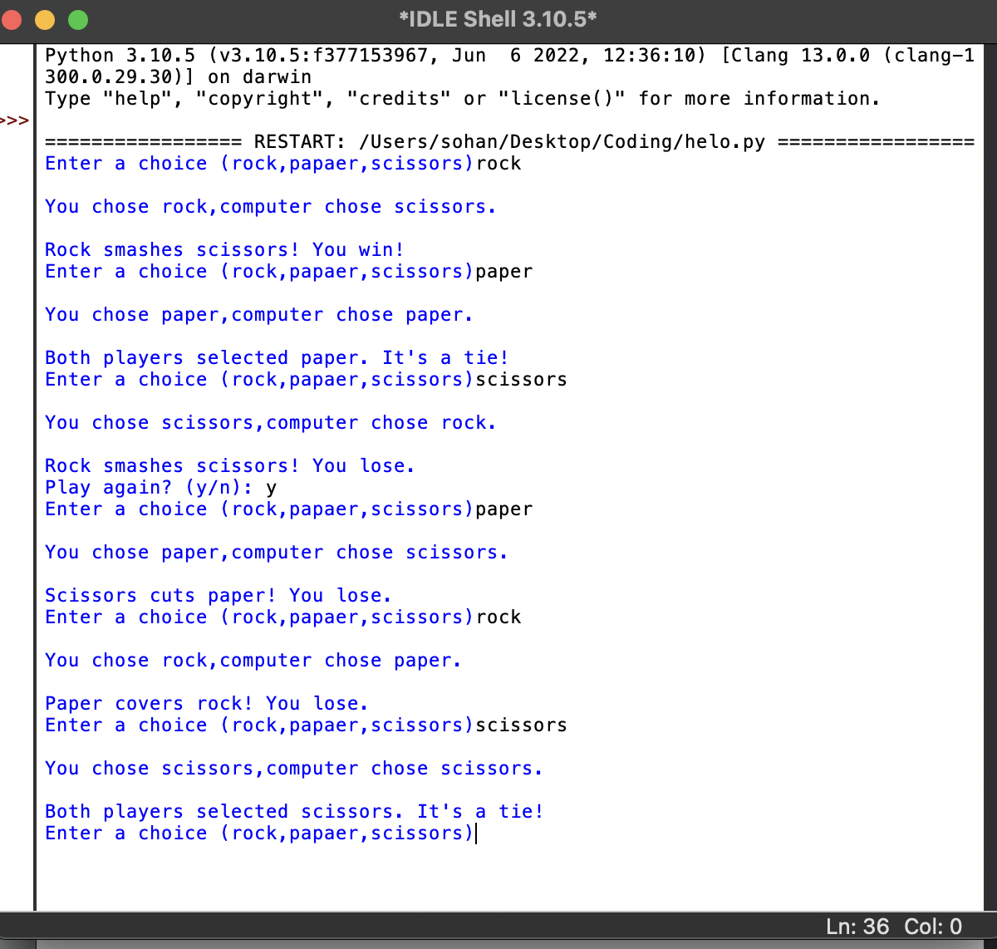

***CONCLUSION***

This program allows the user to play rock-paper-scissors against the computer until they choose to quit the game. The program uses a while loop to repeatedly prompt the user for their choice and display the results of each round. It also keeps track of he number of wins, losses, and ties for both the user and the computer, and displays the final results at the end of the game.